# Lab: HTML Structure

Problems for exercises and homework for the ["HTML and CSS" course @ SoftUni](https://softuni.bg/courses/web-fundamentals-html5). Submit your solutions in the SoftUni judge system at <https://judge.softuni.bg/Contests/395/Lab-HTML-Structure>.

## Navigation Bar

Create a Web Page like the following.

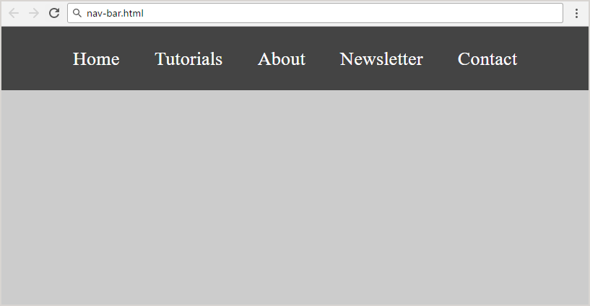

Create two files: **"nav-bar.html"** and **"nav-bar.css"**.

### Constraints

* <nav>tag as container
* <body>
  + Margin: 0px;
  + Padding: 0px;
  + Background Color: #CCCCCC;
* <ul> tag for unordered list
  + Background Color: #444;
  + Center the text
  + Padding: 0px;
  + Margin: 0px;
  + list-style:none;
* <li> tag for list item
  + Text size: 24px;
  + Line Height: 40px;
  + Height: 40px;
  + Padding: 20px;
* <a> tag for hyperlink
  + Text decoration: none;
  + Text-Color: #ffffff;

### Hints

Use:

* <li> with display:inline-block;

## Page Content

Create a Web Page like the following using **"page-content.txt"**.

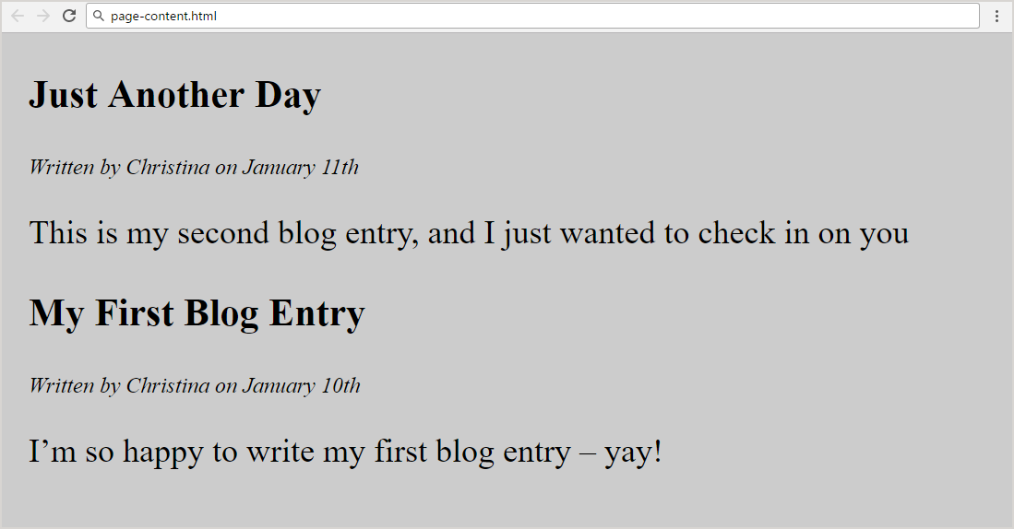

Create two files: **"page-content.html"** and **"page-content.css"**

### Constraints

* <section>as a container
* <article>tag for content
  + <header> with:
    - <h1>Text size: 28px;
    - <p>Font Style: **italic;**
* Paragraph
  + Text size: 24px;
* <body>
  + Margin: 0px;
  + Padding:0px;
  + Background color: **#CCCCCC;**
* **<section>**
  + Margin Left: 20px;

## Simple Website

Create a Web Page like the following

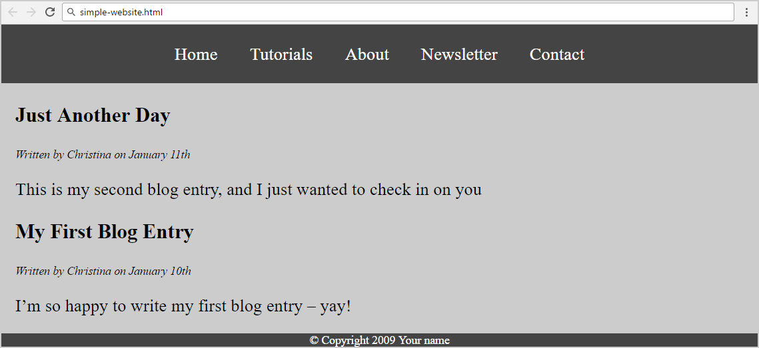

Create two files: "**simple-website.html**"and"**simple-website.css**".

### Constrains

* **Use the html and css from previous two problems**
* <footer> tag
  + Background color: #444;
  + <p> tag for text
  + Text Color: #fff;
  + Center the text

### Hints

Use:

* &copy;for copyright symbol

## Exam Results

Create a Web Page like the following using **exam-results.txt**.

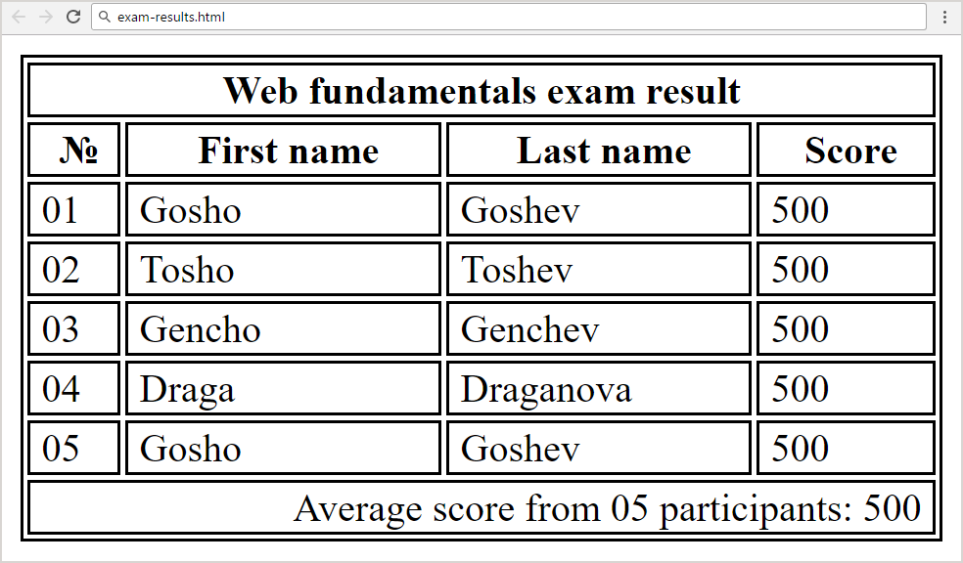

Create two files: "**exam-results.html**" and "**exam-results.css**"

### Constrains

* Border for <table>, <td>, <tr>, <th>
  + 1px solid #000000;
* <thead> with <th colspan="4"> for Table Heading
* <td class="bold"> for bold text
  + Font Weight: bold;
  + Center the text
* <td class="result" colspan="4"> for text in the footer
  + Width: 400px;
  + Text Align: right;
  + Padding Right: 5px;
* Table data
  + Padding Left: 5px;

### Hints

Use:

* &#8470; for number sign